HAMLET:

Act 5

Year 3 and Year 4

Grammar Exercise: Subordinating conjunctions

Conjunctions

A **conjunction** is a type of connective. Specifically, a coordinating conjunction connects two clauses in a sentence.

**For example,** Hamlet **and** Horatio walked towards the castle. The coordinating conjunction in this sentence is **and**

**Conjunctions**

and

yet

but

or

nor

so

Subordinating conjunctions

A subordinating conjunction introduces a subordinate clause (a clause that does not make sense on its own).

**For example,** Hamlet must fight Laertes if he wants a chance of victory.

Conjunctions don’t always appear in the middle of sentences, they can go at the beginning of a sentence.

**For example,** If he wants a chance of victory, Hamlet must fight Laertes.

**Subordinating Conjunctions**

after

because

if

since

though

unless until when

whereas whenever

where why

as soon as

Useful videos https://[www.bbc.co.uk/bitesize/topics/zwwp8mn/articles/z9wvqhv](http://www.bbc.co.uk/bitesize/topics/zwwp8mn/articles/z9wvqhv)

https://[www.bbc.co.uk/bitesize/topics/z4hrt39/articles/zfphsrd](http://www.bbc.co.uk/bitesize/topics/z4hrt39/articles/zfphsrd)

**Exercise 1:** Find the subordinating conjunctions in the wordsearch below. The words go in all directions, including diagonally.

|  |  |  |
| --- | --- | --- |
| after | as | as |
| because | if | since |
| soon | though | unless |
| until | when | whenever |
| whereas | where | why |

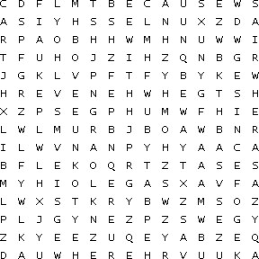

Exercise 2: Complete each sentence. At this stage in the story, Gertrude has accidentally drink the poisoned wine

**Gertrude gasped in pain as soon as she drank the wine.**

**Gertrude gasped in pain because**

**Gertrude gasped in pain but**

**Gertrude gasped in pain and**

**Gertrude gasped in pain when**

HAMLET

Act 5 Year 3 and Year 4 ANSWERS

Exercise 1: Word search

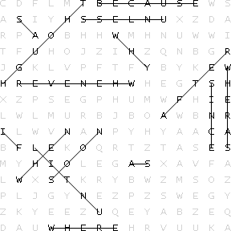

Exercise 2: You can have a whole range of answers for these. Below are some examples.

Gertrude gasped in pain as soon as she drank the wine

Gertrude gasped in pain because she had been poisoned

Gertrude gasped in pain but it was too late.

Gertrude gasped in pain and called out to Hamlet

Gertrude gasped in pain when she realized what had happened.