ACT 1: Setting Description

Act 1 Summary:

Celebration
Caesar returns to Rome after winning the battle against Pompey and the people of Rome celebrate Caesar's return.

Soothsayer
As Caesar is parading back into Rome, he is approached by a soothsayer who shouts ‘Beware the Ides of March’ but Caesar dismisses the warning.

Cassius and Brutus
The senators Cassius and Brutus meet alone and discuss how they feel about Caesar. Cassisus is plotting against Caesar. Brutus is an honourable man.They both agree that Caesar has too much power and that this could be dangerous. Cassius implies that he has a plan and Brutus promises to consider it. Caesar sees them and tells Antony that Cassius has a ‘lean and hungry look’.

Caesar as King?
Casca (another senator) tells Brutus and Cassius that Antony offered Caesar a crown however Caesar refused it. Even though Caesar refused the crown three times, Casca is still convinced that Caesar wants to become king.

Cassius and the Conspirators
Cassisus believes that he can manipulate Brutus’ noble nature to join him in their plot to destroy Caesar. He meets with the other conspirators (Casca and Cinna) to formulate a plan.

Week 1 - Lesson 1: Rome Soundscape (Drama Lesson)
Learning Intention | To create a soundscape for a scene
Key Vocabulary | setting, scene, soundscape, freeze frame, tableau
Activities/  Lesson | Introduction  Explain that the play starts with the citizens of Rome celebrating Caesar who has won the battle against Pompey. Introduce the concept of a soundscape - a combination of sounds that create a specific environment or scene. Introduce the setting of the opening scene of Julius Caesar, emphasizing Caesar's triumphant return and the citizens' celebration in ancient Rome.The city has the day off as a holiday to celebrate! Show the children the following clip. (Teachers should watch all video clips before the lesson to check that they are appropriate for their class).  Animated Tales (0:00- 0:29). https://www.youtube.com/watch?v=7DtJkeMK0yU  Triumph of Caesar (1:50 - 2:33) https://www.youtube.com/watch?v=3GJLfHj9lfE  Show the children pictures/illustrations of ancient Rome to help students visualize the setting.  Warm-up Activity - Freeze Frame  Divide the class into small groups. Assign each group a specific moment from the opening scene, such as citizens cheering, soldiers marching, or Caesar's grand entrance. Ask each group to create a frozen tableau depicting their assigned moment. Encourage them to think about facial expressions, body language, and the overall mood of the scene. Have each group present their freeze frame to the class while discussing the sounds they imagine would accompany their scene.  Main Activity - Creating a Soundscape  Play the following clip again but this time, instruct students to close their eyes and listen carefully to the sounds. Triumph of Caesar (1:50 - 2:33) https://www.youtube.com/watch?v=3GJLfHj9lfE Ask them to imagine being in the scene and experiencing the celebration. Did they hear the citizens shouting? What were they saying? ‘we love you Caesar’, ‘Glorious Caesar’ and repeated chanting of his name. Ask whether they heard any other sounds (loud cheering, trumpets blaring, horses hooves, horses neighing, clapping, roaring cheers etc). Divide the class into small groups again and provide each group with a list of sounds and cheers from the crowd (see above) they need to recreate using their voices and bodies (cheering, drumming, trumpets, etc.). Allow time for each group to practice and refine their soundscape. Have each group perform their soundscape for the class, and discuss the different elements they included to represent the scene. Finally ask the children to perform their scenes at the same time to model the scale of noise, celebration and atmosphere of the scene.  Reflection and Writing Preparation  For the last part of the lesson, ask the children to reflect on their experience creating and performing the soundscape. What did they learn about the setting? How did the sounds contribute to the atmosphere? Discuss as a class and write a list of descriptive words or phrases that capture the mood of the scene (display this on the classroom working wall). Explain that they will use these words and phrases to write a setting description for the opening scene of Julius Caesar in the following lessons.
Notes for Teachers | This lesson aims to engage students in a multisensory experience, immersing them in the atmosphere of the opening scene and preparing them for the upcoming writing task.
Resources | Animated Tales (stop at 0:29). https://www.youtube.com/watch?v=7DtJkeMK0yU  Triumph of Caesar ( 1:50 - 2:33) https://www.youtube.com/watch?v=3GJLfHj9lfE  Pictures or illustrations of ancient Rome for inspiration  Large open space for movement

Week 1 - Lesson 2: Using our Senses
Learning Intention | To use the senses to gather descriptive vocabulary
Key Vocabulary | setting, sight, sound, touch, taste, smell, vivid, powerful
Activities/  Lesson | Introduction  Start the lesson by asking the children - what is a setting? Ask for their input then explain that a setting is the environment/surrounding that a story takes place in. Briefly discuss the importance of creating a vivid and powerful scene when describing a setting with the children. Explain how we can use the five senses: sight, sound, touch, taste, and smell to describe a setting. Remind the children of what they did in yesterday’s drama lesson and explain that we have used one of the five senses (sound) to help us to eventually write a setting description.  Exploring the Senses  Divide the class into four groups, assigning each group with each of the remaining senses (sight, touch, taste and smell). Within each group, the children can work in pairs or threes to complete the following task. Ask each group to brainstorm words and phrases related to their sense in the context of a festive celebration. For example, for sight, students might suggest "colourful banners" or "joyful faces." Note that the groups assigned to touch, taste and smell might need more adult support to use their imagination and generate their phrases. Children can use images of ancient Rome and video clips from the previous lesson to help them generate ideas. Ask the pairs/threes to record their phrases onto A3 Paper.  Sharing  Have each group share their collected words and phrases with the class. Create a list on the board, organising the vocabulary under the headings of the different senses.  Quick Write  Distribute a template for a setting description (see resources) and ask students to incorporate the sensory vocabulary they've collected (displayed on the board) to write sentences in each section of the Describe Using Senses template (could be printed on as A3 for more space). Encourage them to be creative and vivid in their descriptions and emphasise that this quick write is to allow them to jot down and bring ideas together for each sense. Explain that this is not the final piece and encourage them to write freely, drawing on the ideas that they have generated as a class.  Plenary  Ask for children to share their work with the class and end the lesson by explaining the importance of sensory details in making writing more engaging.
Notes for Teachers | This lesson is for children to collate the shared ideas to help them memorise language as well as using other’s ideas to create their own sentences.
Resources | Animated Tales (stop at 0:29). https://www.youtube.com/watch?v=7DtJkeMK0yU  Triumph of Caesar ( 1:50 - 2:33) https://www.youtube.com/watch?v=3GJLfHj9lfE  Pictures or illustrations of ancient Rome for inspiration  Describe Using Senses template (see resources)

Week 1 - Lesson 3: Language Devices
Learning Intention | To use personification and similes to excite the reader
Key Vocabulary | similes, personification, like, as, inanimate object, vivid, language device
Activities/  Lesson | Review  Briefly review the previous lesson's key points on describing using our senses and the importance of creating a vivid and powerful image in the reader’s mind.  Introduction to Personification  Explain personification and provide examples for the children. Discuss how personification can bring inanimate objects (‘things that are not alive’) to life and enhance the atmosphere of a setting.  Group Activity - Personification  Divide the class into small groups. Assign each group an inanimate object from the scene (e.g. banners, marble columns, the sun or the streets of Rome). Ask each group to brainstorm how to personify their assigned object and incorporate it into their setting description. Collect a few examples and write them up on the board.  e.g.  The sun smiled warmly on the bustling streets of Rome  The marble columns stood like wise old storytellers, whispering tales of emperors and gladiators.  The banners fluttered in the breeze, waving like cheerful children.  Introduction to Similes  Introduce the concept of similes as a language device. Explain that we use similes to compare two different things using the words "like" or "as" to create a picture in the reader’s mind. Provide examples for children to explore- not necessarily linked to this particular context.  Individual Writing - Similes  Give the children elements from the setting that they can write similes for e.g. the crowd, the cheers, the atmosphere, the city square, the streets etc. Model writing a simile and then ask children to write their own for each element  e.g.  The crowd surged forward like a mighty river.  The cheers erupted like a volcano, spewing joy and adulation for Caesar.  The atmosphere was as charged as a stormy sky.  The city square bustled with excitement like a beehive full of busy bees.  Laughter and cheers echoed through the air like joyful fireworks on Bonfire Night.  The crowd swirled around Caesar like leaves caught in a playful breeze.  The streets were as vibrant as a rainbow, filled with people in colorful robes, waving flags and banners.  Sharing and Feedback  Have the children share their personifications and similes. Provide positive feedback and discuss how these literary devices enhance the overall quality of the writing.
Notes for Teachers | Refer back to any previous learning of similes and personification. You could use images, video clips and passages from different versions of the play to support the children in building a mental image of the setting.
Resources | Animated Tales (stop at 0:29). https://www.youtube.com/watch?v=7DtJkeMK0yU  Triumph of Caesar ( 1:50 - 2:33) https://www.youtube.com/watch?v=3GJLfHj9lfE  Pictures or illustrations of ancient Rome for inspiration
Week 1 - Lesson 4: Write
Learning Intention | To write a setting description
Key Vocabulary | soundscape, senses, sight, sound, touch, tast, smell, similes, personification, adverbials, time, manner, place
Activities/  Lesson | Read the excerpt from Julius Caesar by Andrew Matthews and Tony Ross (P7-9) aloud to the class to set the scene for the children. You could read an excerpt from any version of the play that describes the opening scene. Explain that today they will use the ideas and language that we have built over the last few days to write a setting description of the opening scene of the play. Recap the learning and language from lesson 1, 2 and 3.  Sentence Starters  Provide a list of sentence starters for the students. Examples could include:  In the heart of Rome, …  With joyous cheers, ...  Beneath the bustling crowd, ...  Amidst the grandeur of the city, ...  As the sun dipped below the horizon, ...  Explain that using different sentence starters will make their writing more engaging. Give the children time to work with a partner to orally rehearse using the sentence started to create sentences for their setting description.  Discuss the concept of adverbials and their role in providing additional information about when, how or where (time, manner and place) an action takes place. Provide a list of fronted adverbials (see below for examples) and ask the children to identify whether they describe, time, manner or place.  Triumphantly,  Excitedly,  In the radiant sunlight,  At midday,  Then, give the children time to work with a partner to orally rehearse using the sentence starters to create sentences for their setting description.  Write  Remind children of the language and ideas generated from lessons 1 - 3. This could be displayed on the walls or children could look back in their books before and during writing. Show an example setting description that includes all the skills practised in all 4 lessons.This should be written prior to the lesson. Allow children time to write their setting descriptions. Ensuring that they have access to the ideas generated from lessons 1, 2 and 3.
Notes for Teachers | See resources for an example setting description however it is advised that teachers prepare their own examples, using ideas and examples from the children in their class.
Resources | An example setting description prepared by the class teacher before the lesson  Pictures or illustrations of ancient Rome for inspiration  Ideas from lessons 1, 2 and 3 could be up on the working wall from which the children can refer to as they write their setting descriptions.

Week 1 - Lesson 5: Self and Peer Assessment
Learning Intention | To assess writing and to make edits and improvements
Key Vocabulary | soundscape, senses, sight, sound, touch, tast, smell, similes, personification, adverbials, time, manner, place
Activities/  Lesson | Allow children time to finish their setting description if needed.  Self and Peer Assess  Explain that today we will be self-assessing and peer-assessing our writing. Model using the setting description checklist (see resources) to self-assess a setting description.  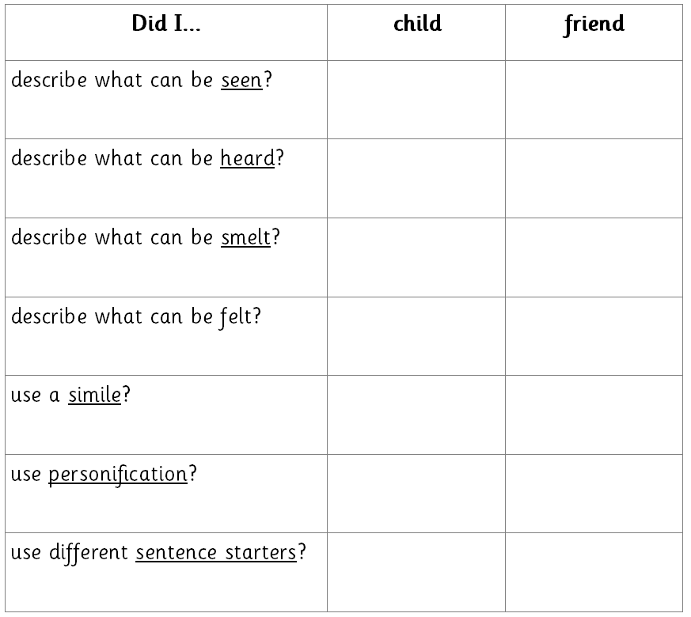  Explain that once the children have used the checklist to see whether they have addressed all the elements in the list, they can edit and improve their writing. They can then work with a partner so that they can read each other’s work and fill in the final column of the checklist. Explain that even if all items on the list are ticked, they can still make suggestions on ways to improve the writing further.  Share  When children have completed assessing, editing and improving, ask for volunteers to share their work.
Notes for Teachers | Your school might have their own procedures on how children should self/peer assess writing. We suggest that you follow your school’s English policy. The aim of this lesson is to provide space for children to reflect on and improve their writing.
Resources | Self and Peer assessment checklist

Resources

Describe Using Senses 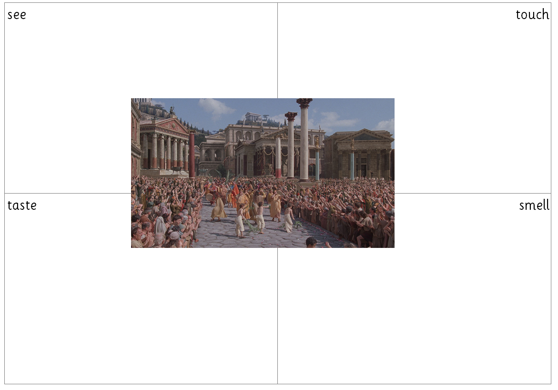

Example Setting Description

We advise that teachers prepare their own examples, using the ideas from the children in their class.

In the heart of Rome, heaving crowds gathered to witness almighty Caesar’s return. The streets wiggled with joy as people celebrated and sang songs of triumph and victory. Red and golden banners fluttered in the breeze, waving like cheerful children casting streaks of colour against the blue sky. In the midday sun, the air smelt like a mix of sweat and sweet aromas from the street vendors. The crowd took on a life of its own, moving as one surging like a mighty river pushed by the brewing winds of an impending storm. All of sudden, cheers erupted, spewing joy and adulation for Caesar. Cheers so loud it felt as though it shook the foundations of the city. “Glorious Caesar!’ echoed through the air. Citizens chanted to the the rhythm of their footsteps echoing his name far and wide. Excitedly, little children scuttled amongst the forest of dancing legs to get a better view while their parents were too busy to notice. The sound of hooves and wooden wheels grew louder as Caesar made his way into the heart of Rome. The city square bustled with excitement like a hive of busy bees protecting their queen as towering marble columns stood watching wisely- they had witness enough leaders come and go to know that such joyous celebrations were often short-lived.

Self and Peer Assess

