ACT 4: Brutus’ Diary Entry

Act 4 Summary:

Antony, Octavius and Lepidus
Antony, Octavius (Caesar’s heir) and a senator called Lepidus join forces to defeat the conspirators

Argument
Cassius and Brutus argue and it gets personal. The argument leads to Brutus challenging Cassius to murder him. They both calm down and Brutus reveals that he is upset because his wife Portia has killed herself.

To Phillippi
Brutus and Cassius hear that Antony and Octavius are traveling to Phillippi. Cassius thinks that they should let Antony and Octavius come to them so that they will be tired out. Brutus disagrees and they end up leaving camp to head to Phillipi.

Caesar’s Ghost
When Brutus is alone, he is visited by Caesar’s ghost. The ghost professes to be an evil spirit and disappears before Brutus can talk with the ghost.

Week 4 - Lesson 1: Drama - Being Brutus
Learning Intention | To infer the thoughts and feelings of a character
Key Vocabulary | thoughts, feelings, events, chronological order
Activities/  Lesson | Warm- Up  Ask the children to walk around the room utilising all the space without bumping into each other. Tell them that when you clap twice they have to change direction and when you clap once they have to freeze. Practise this to encourage good listening. Stop them and explain that now you will clap once (for freeze) and shout out a key event that has happened to Brutus and they have to freeze frame that moment. When you clap again, they will unfreeze and continue walking around the room. Repeat this with different events that have happened to Brutus (see resources).  Main Activity  Tableaus  Organise the children into groups of 5 and give each group a set of Events of Brutus (see resources) cut into strips and ask them to order them in chronological order. Once they have ordered the events, explain that today they will work in their groups to create tableaus (freeze frames) of each event in order. The children can take turns being Brutus in each tableau while the others are supporting characters within the scene. Explain that they must think about the following things in order to create an effective tableau.  - Facial expressions  - Focal point (where do you want to lead the audience’s eye towards?)  - Dynamic body positioning  - Levels in the tableau (a mix of low, middle and high positioning of characters)  Discuss and demonstrate each point. Tell them that they will have time to create and rehearse their tableaus before performing them to the rest of the class with a backing track (to be selected prior to lesson). Play the selected backing track for them to listen to. Ask them how the piece of music makes them feel? Why do they think you have chosen this piece? Allow children time to rehearse then have each group perform their series of tableaus to music.  Tableaus and Inner Thoughts  After they have performed their tableaus, tell them that they will now add Brutus’ inner thoughts to each tableau. Go through each event and ask children to think of inner thoughts that would be going through Brutus’ head at the moment. Encourage the children to empahise with the character and imagine being in his shoes. Allow the children to work in groups to write down 3 or 4 thoughts per tableau. Once the children have generated a fews ideas for each tableau tell that that they need to incorporate a couple into each tableau. Allow them time to rehearse and perform again to music. Each time they freeze the child who plays Brutus is the only person who will unfreeze to deliver their lines- everyone else should remain still for effect.
Notes for Teachers | The aim of this lesson is to get the children to remember the events that the character Brutus has experienced alongside encouraging the children to consider his inner thoughts and feelings
Resources | Events of Brutus (see resources)  Dramatic background music for performing

Week 4 - Lesson 2: Brutus’ Key Events
Learning Intention | To infer the thoughts and feelings of a character
Key Vocabulary | perspective, point of view, recount, diary,
Activities/  Lesson | Introduction  Explain that this week they will be writing a diary entry from the perspective of Brutus. Discuss the character Brutus with the children. Explain that he is often described as a tragic hero. The character Brutus loved Caesar as a friend but loves the people of Rome even more. He believes that joining the conspirators to kill his good friend Caesar is the right thing to do in order to save Rome - as he knows from history that having a single ruler (king) does not turn out well for the people. Brutus is a complicated character because although he took part in murdering Caesar, he is not a wholly bad character. Ask the children- Now that we’ve discussed the character Brutus, how do you think he felt inside? How would you feel inside if you had to make such a decision? Jot down their ideas on the board. E.g. Torn, conflicted, troubled, worried all the time, wanting to change your mind etc. Tell the children that these feelings need to come through when they write Brutus’ diary entry. Keep the list of feelings up on the working wall to remind them.  Main Teaching  Explain that the diary entry will be written just after Brutus sees Caesar’s ghost and in the diary entry we will cover the following events in order:  - The murder of Caesar  - Fleeing Rome  - Finding out that his wife Portia has killed herself  - Seeing Caesar’s ghost  Tell them that today they will be working in pairs/threes to further explore the thoughts of feelings of Brutus during the 4 events. Give each group a large piece of paper (A2 or A3x2) and ask them to create a visual timeline/map of the 4 events. They can format their timeline/map however they want. Give each group small Post-its. Explain that they can write Brutus’ thoughts/feelings for each event on the Post-its and stick it around each event. They can draw each event so that they have a visual representation of Brutus’ experience since the Ides of March. Model doing this for the event 1- The murder of Caesar. E.g. Post-its = ‘It was the hardest decision of my life but I had to do it!’ ‘I love Caesar as a friend but I must protect Rome.’ ‘It was the hardest thing I’ve ever done.’ ‘Everytime I close my eyes I see his lifeless body.’ Encourage the children to come up with at least 3 thoughts for each event.  Activity  Allow children time to create their Brutus timeline/map. Encourage them to make it visual and to be creative! These can be put up on the wall as visual reminders of Brutus’ experience/journey and will be referred to before/while they write later on in the week.
Notes for Teachers | The aim of this lesson is for the children to further explore Brutus’ experience. The more visual and creative they are in creating the timeline/map the better. The work from this lesson will be used later on when writing.
Resources | Large pieces of paper (A3 x 2) per group  Post-it notes for thoughts and feelings per group  Scrap paper, coloring pencils, glue
Week 4 - Lesson 3: Caesar’s Ghost
Learning Intention | To describe an event in detail
Key Vocabulary | perspective, detail, describe, adjectives
Activities/  Lesson | Introduction  Show the children pictures of Brutus seeing Caesar’s ghost (see resources). Explain that the most recent event Brutus will write about is the sighting of Caesar’s ghost. How would you feel if you were Brutus and saw Caesar’s ghost? What might you say to yourself? Ask the children to feedback their ideas.  Main Teaching  Explain that today we will focus on describing the ghost from Brutus’ perspective as we will write about seeing the ghost in the diary entry. Ask them what kind of words do we use when describing? (adjectives). Ask them to describe the two images of Caesar’s ghosts - encourage them to describe in detail. Tell them that they can be creative when describing Caesar’s ghost- it doesn’t have to look like the pictures here but they can draw inspiration from the pictures. Ask the following questions and model jotting down descriptive sentences/phrases around a picture of Caesar’s ghost.  - What did Brutus hear when he saw the ghost?  - Describe the ghost’s face, eyes, body.  - How did it feel in the room? (cold, still, eerie)  - What does the ghost say to Brutus?  Activity  Tell the children that today they will draw their version of Caesar’s ghost and write their description of the ghost/event (prompted by the questions above) around their picture.
Notes for Teachers | This lesson will help the children think about the most recent event that they will recall when writing the diary entry. As it is the most recent event to happen to Brutus it will also be the most vivid from his perspective thus the children should write in more detail about this particular event.
Resources | Pictures of Caesar’s ghost (see resources)

Week 4 - Lesson 4: Features of Diary Entry
Learning Intention | To identify the features of a diary entry
Key Vocabulary | common features, success criteria
Activities/  Lesson | Introduction  Display an appropriate diary entry (not related to Julius Caesar) on the board and ask the children to read it aloud in pairs. Discuss what they have just read together and ask them- How do you know that this is a diary entry? E.g. starts with ‘Dear Diary’, written in first person etc.  Main Teaching  Explain that before we write a diary entry from the perspective of Brutus, we must be really clear on what a diary entry looks like and must include. Today we will create our own success criteria for a diary entry. Tell them that there are a selection of diary entries on their tables. Their job today is to work with a partner to read them all and decide on the common features that we must include in a diary entry. Agree on one together as a class and write that on the board.  Activity  Allow children time to read the diary entries on their tables to spot the common features.  E.g. Dear Diary, written in first person, past tense, paragraphs, thoughts and feelings, chronological order. Ask them to write them down on a whiteboard, ready to share with the class.  Plenary  Ask the children to share their findings and create a final checklist/success criteria on a flipchart (see resources for an example). Display the flipchart on the working wall.
Notes for Teachers | The aim of the lesson is to embed the features of a diary entry so that they are clear on what to include when writing in the next lesson.
Resources | Sources examples of age-appropriate diary entries for the children to explore/highlight.  Features of a diary entry checklist (see resources)

Week 4 - Lesson 5: Write
Learning Intention | To write an diary entry from the perspective of a character
Key Vocabulary | perspective, thoughts, feelings, chronological order, first person
Activities/  Lesson | Introduction  Recap with the children what they did in lessons 1, 2, 3, and 4. Refer to examples of their work on the working wall to remind them. Explain that today we will use all of that work to write a diary entry as Brutus.  Main Teaching  Shared Writing  Ask the children to help you write the beginning of Brutus’ diary entry. Display one of the timeline/maps created by the children and model using it as a plan to support your writing. Model thinking aloud when writing. Explicitly refer to the thoughts and feelings Post-its when writing.  Independent Activity  Display the following starter on the board for those who wish to use it.  Dear Diary,  The past few days have been chaos. So much has happened.  Tell the children to use their timeline/map from lesson 2 to support them in writing their diary entry.  Plenary  Children swap work with a partner and support each other to edit and improve their writing.
Notes for Teachers | The children might benefit from a generic word bank and sentence starters to support their writing.
Resources | Timeline/maps from lesson 2 given out for children to use when writing

Resources

Events of Brutus

Brutus strikes Caesar with the final blow

Brutus speaks to the crowd

Brutus and Cassisus flee Rome

Brutus discovers that his wife has killed herself

Brutus sees Caesar’s ghost

Caesar’s Ghost
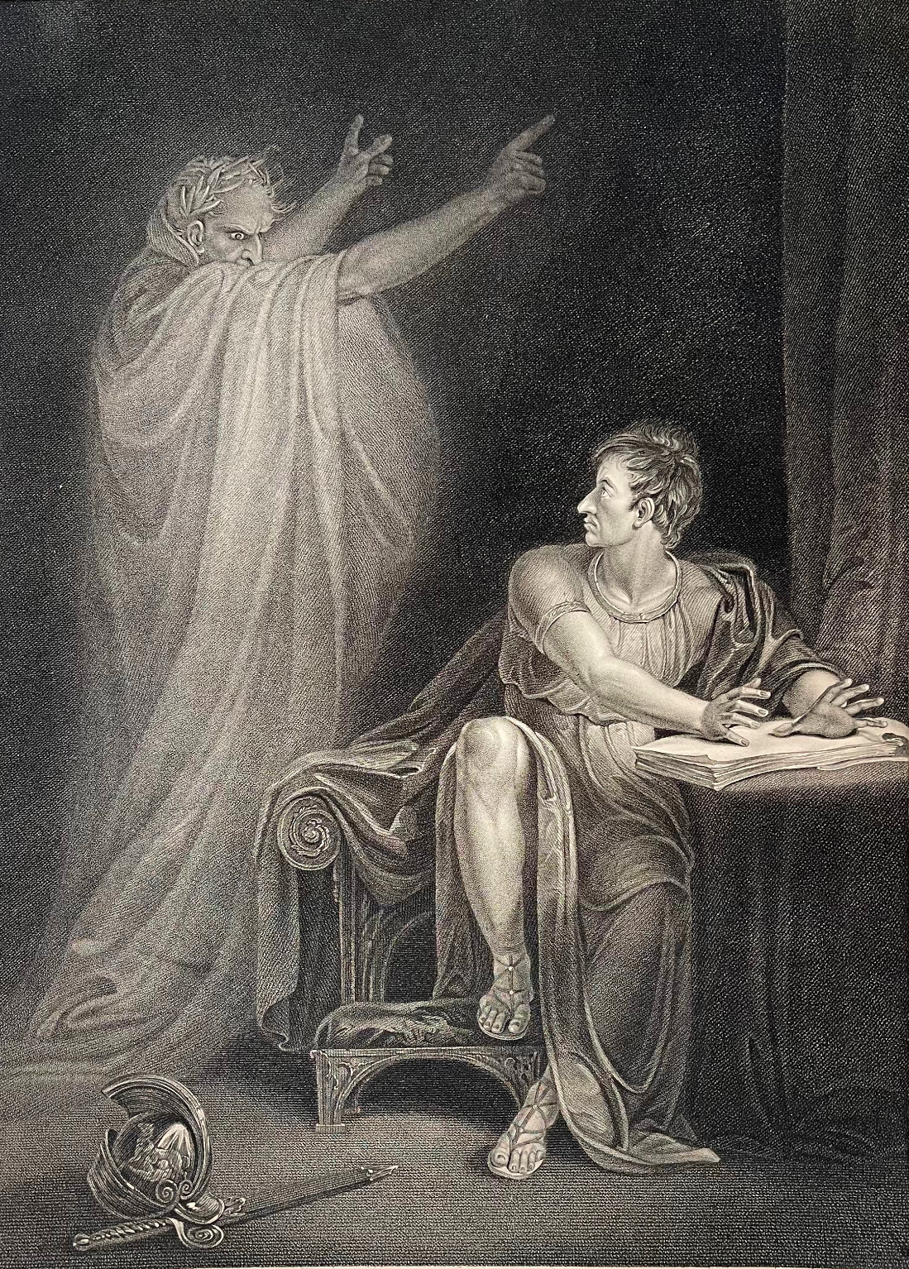
Engraving of Act IV Scene III of Shakespeare's Julius Caesar with transcription of scene underneath image. Painted by: R. Westall Engraved by: Edward ScrivenPublished by: John and Josiah Boydell, Shakespeare Gallery, Pall Mall & No. 90, Cheapside, London

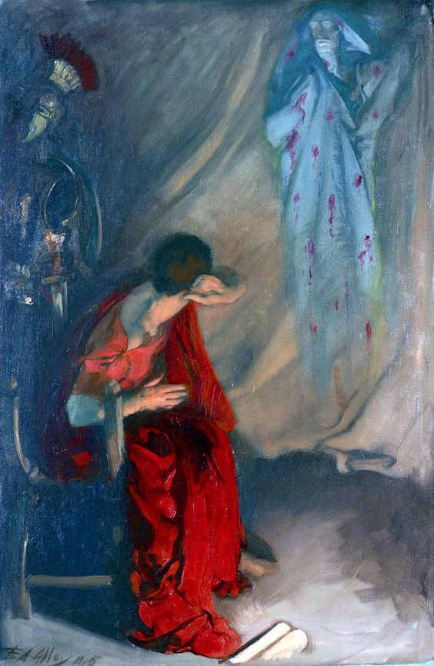
Julius Caesar: Within the Tent of Brutus: Enter the Ghost of Caesar, (Act IV, SceneIII)’Edwin Austin Abbey, American, 1852–1911. The Yale University Art Gallery

Images of Ghost (stick in if not drawing)

Features of a Diary Checklist

Features of a Diary Checklist
Uses the past tense
Uses first person pronouns (I, we, my, etc.)
Describes the writer’s point of view, thoughts and feelings
Uses ambitious words to describe people and places
Is written in an informal style, as though speaking to someone
Uses time conjunctions to link events
Organises events into paragraphs

