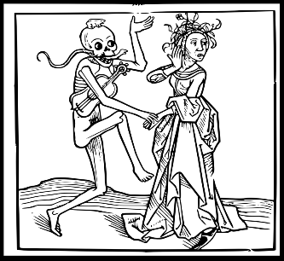
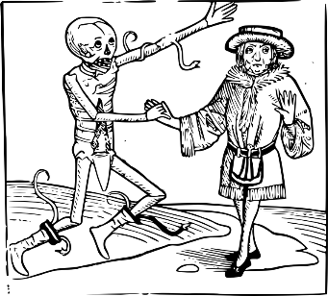
++‘Here in this city visiting the sick, And finding him, the searchers of the town,
Suspecting that we both were in a house. Where the infectious pestilence did reign,
Sealed up the doors and would not let us forth.
Friar John talks of an infectious disease and was quarantined in a house that he had been
visiting.

Compare and order the death rate of infectious diseases that affected Verona around and after when Romeo and Juliet was set.

Disease | Year | Approximate Deaths in Verona | Compare the death rate (Write 1st, 2nd, 3rd… 1st is the largest) | Write the number in words
Bubonic plague | 1346–1353 | 984
Influenza pandemic | 1510 | 809
Influenza pandemic | 1557–59 | 911
Italian plague | 1629–1631 | 897
Naples Plague | 1656 | 860
Sicily plague epidemic | 1743 | 922

