The Primary Shakespeare Company (PSC) are practising Act 5, Scene 3. They need to ensure they have all of the props ready for when the actors arrive so they visit a prop hire company. Help the PSC to work out the following problems so they know how many props they’ll have…

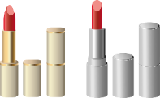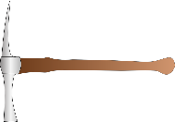Coins, Money, Pennies, Cent, Gold Coin, Silver Coin

6.

In a box, there are 14 envelopes, 15 piece of paper and 5 quills, costing £3.25. PSC want 13 quills. How many envelopes will they also have to purchase and how much they will they have to pay?

9.

In a crate, there are 16 shovels and 13 lanterns. The PSC need 33 shovels and 39 lanterns. They buy 2 boxes. How many short of each item will they be?

8.

In a container there are 3 different shades of red lipstick: 4 rose, 5 burgundy and 3 sunset. The PSC need exactly 48 lipsticks. How many boxes should they buy?

1.

In a box, there are 7 torches. The PSC need 23 torches. Each box costs £4. How much will they need to spend?

2.

In a bag, there are 17 yew tree branches, costing £8. The PSC need 39 branches. How much will they cost?

4.

In a bouquet, there are 13 roses and 8 lilies, costing £5. The PSC buy 9 bouquets. How much will they cost?

5.

In a crate, there are 11 mattocks and 9 wrenching irons, costing £4.50. The PSC buy 4 boxes. How much will they cost?

7.

In a bag, there are 14 gold coins, 8 silver coins and 9 bronze coins, costing £5.30. The PSC need 15 gold, 17 silver and 15 bronze. How many bags will they have to buy and how much does it cost?

3.

In a crate, there are 12 tombstones and 9 crosses, costing £6. The PSC want 15 tombstones and 19 crosses. How much will they cost?