Juliet’s Relationships
In Act 4, Scene 3, after Juliet’s ‘death’, each character’s reaction says a lot about their relationship with Juliet. The people in Juliet’s life reflect on their relationship but how old are they all. The age of each person is the missing number…

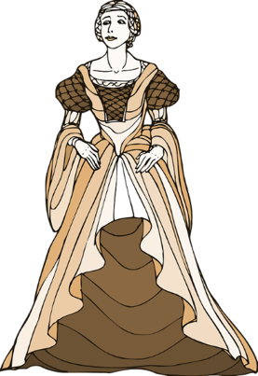
- I am Juliet… 6. I am Juliet’s suitor, Paris.
How old am I? How old am I?
88 - 69 =
47 - = 34

- I am Juliet’s Father, Capulet. 7. I am Juliet’s nurse’s servant, Peter.
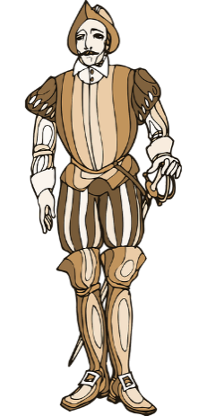
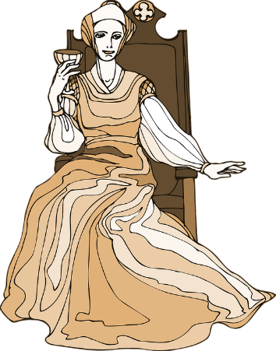
How old am I? How old am I?
97 - = 32
+ 15 = 52

- I am Juliet’s mum, Lady Capulet… 8. I am the musician supposed
How old am I? to play at Juliet’s wedding to
Paris. How old am I
- 13 = 19
+ 41 = 71

- I am Juliet’s friar…
Can you write your own missing number problem using your age predictions of other characters not in this scene?
How old am I?
18 + = 67

- I am Juliet’s Nurse…
How old am I?
84 - = 31

