Juliet is distraught when Friar Lawrence tells her that there’s nothing he can do anything to prevent her having to marry Lord Paris. She is desperate for a way out so Friar Lawrence hatches a plan. He says that Juliet can take a potion that mimics death, ‘The roses in thy lips and cheeks shall fade. To paly ashes, thy eyes' windows fall, 100. Like death, when he shuts up the day of life’.
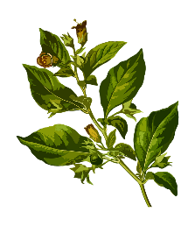
Potions and poisons were often made using plants. Work out how much of each ingredient is needed for the potion:

5 lots of 8ml of yew…
11 lots of 4ml of deadly nightshade…
7 lots of 4ml of hemlock…
8 lots of 8 ml of wild pansy…

12 lots of 3ml of wild rosemary…
12 lots of 6ml of
crushed bulrush…
9 lots of 8ml of ebony…
7 lots of 7ml of leopard’s bane…

4 lots of 9ml of peaseblossom…
6 lots of 9ml of mustard seed…
8 lots of 6ml of violets…
12 lots of 7ml of fennel…

W

Write 3 multiplication (12x12 timetables) problems about ingredients for your own poison. Make them different to the ones above. Ask a peer to solve the problems.

