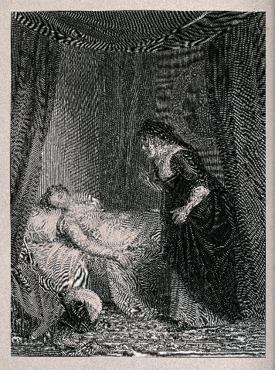
Juliet’s Bedroom
Act 4, Scene 5 takes place in Juliet’s bedroom, where the Nurse finds her
‘dead’… The Primary Shakespeare Company are dressing their stage for this scene.
Help them to work out what they need to prepare the scene…
If the number is written in numerals, convert it to words and if the number is
written, convert it into numerals.

- They need nine hundred and ninety-five millilitres of gold paint for the bed.

- They will need seven hundred and fifty-nine minutes to paint the room.

- They need one thousand two hundred and forty cm in length of wood to build the chest of drawers

- For the curtain ties, two thousand one hundred and eight green gold threads and ninety-four cream.
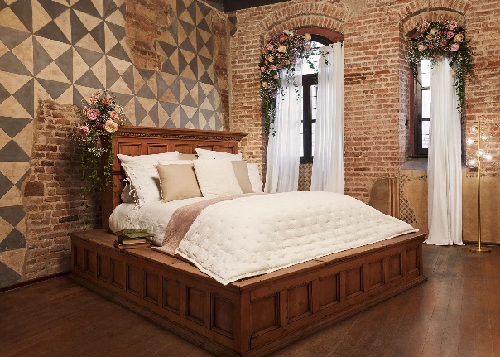

- 2435 paste-coloured roses

- 1911 tea light candles

- 3787 bricks for one stage wall

- Three thousand one hundred and sixty-one feathers for the duvet.

Write 4 of your own sentences that include numbers written as words for a partner to convert.

