Theseus’ Athenian Palace

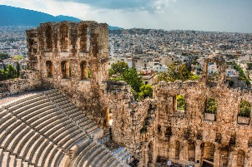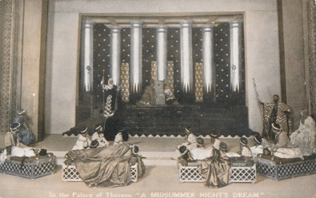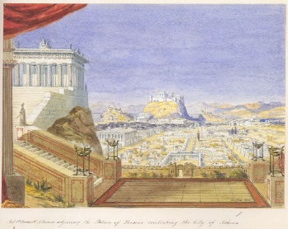

Help measure the different rooms in Theseus’ palace.

**[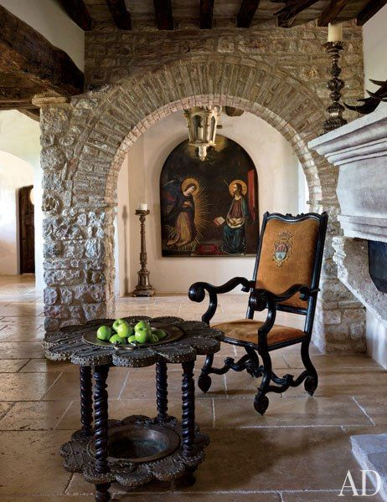](http://www.architecturaldigest.com/decor/2013-11/martyn-lawrence-bullard-evgeny-lebedev-domenico-minchilli-umbria-italy-castle-slideshow_slideshow_After--Dining-Room_12)**

1. Theseus’ bedroom

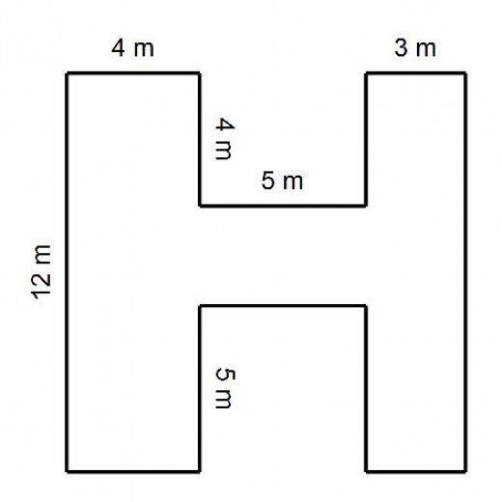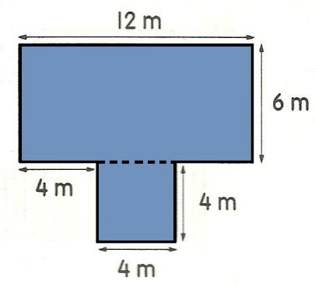

1. Theseus’ entrance way

[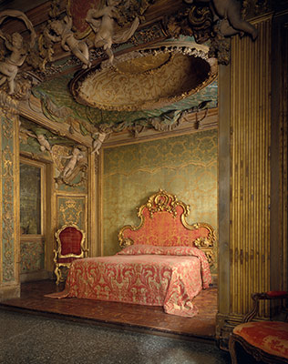](https://www.google.co.uk/url?sa=i&rct=j&q=&esrc=s&source=images&cd=&cad=rja&uact=8&ved=0ahUKEwi27o6PhsjYAhVaOMAKHfzGAcUQjRwIBw&url=https://www.metmuseum.org/toah/ht/09/eustn.html&psig=AOvVaw3ha8JuhB9Ps6ij3Tsb3ter&ust=1515489939824480)

[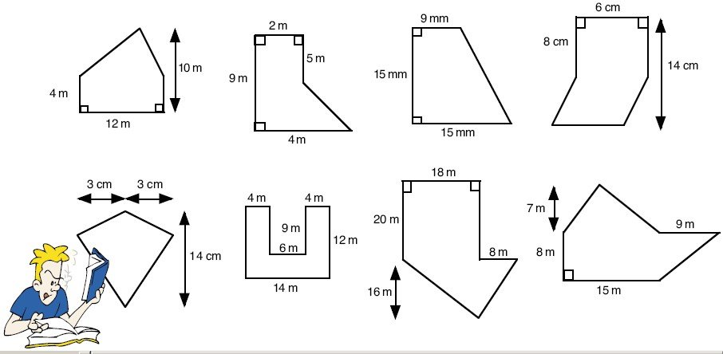](https://www.google.co.uk/url?sa=i&rct=j&q=&esrc=s&source=images&cd=&cad=rja&uact=8&ved=0ahUKEwiNrcn6z8jYAhViJcAKHZIqCTMQjRwIBw&url=http://slideplayer.com/slide/6815005/&psig=AOvVaw0u1lg95teDdX2nrsApzJ1k&ust=1515509276253464)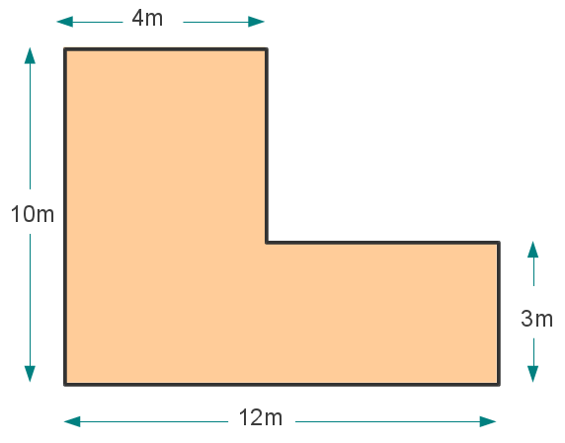[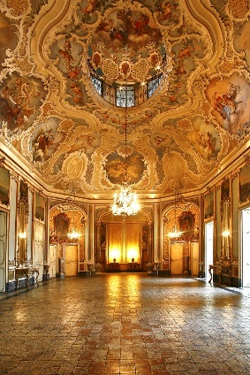](https://www.google.co.uk/url?sa=i&rct=j&q=&esrc=s&source=images&cd=&cad=rja&uact=8&ved=0ahUKEwiX7p3U_sfYAhXLKsAKHTHeAecQjRwIBw&url=https://www.pinterest.com/keepstrying/castles-and-palaces/&psig=AOvVaw2Bf3P2MvD3z_Sm9ECHnsRO&ust=1515487919920156)

1. Ballroom
2. Court
3. Kitchen

[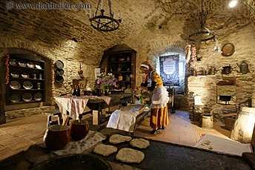](https://www.google.co.uk/url?sa=i&rct=j&q=&esrc=s&source=images&cd=&cad=rja&uact=8&ved=0ahUKEwi54cPDicjYAhXlJ8AKHZDsAnMQjRwIBw&url=https://www.pinterest.com/pin/844493650975513/&psig=AOvVaw3uypFv0CYYNgeqBfxg5dwa&ust=1515490239990160)

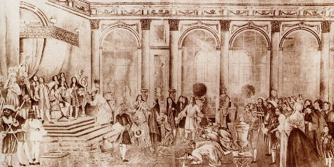

[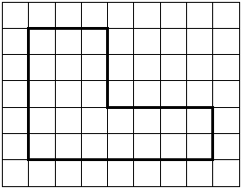](https://www.google.co.uk/url?sa=i&rct=j&q=&esrc=s&source=images&cd=&cad=rja&uact=8&ved=0ahUKEwjbyt3JzsjYAhXBJMAKHbLmBHEQjRwIBw&url=http://www.cimt.org.uk/projects/mepres/book7/bk7i9/bk7_9i4.htm&psig=AOvVaw0u1lg95teDdX2nrsApzJ1k&ust=1515509276253464)[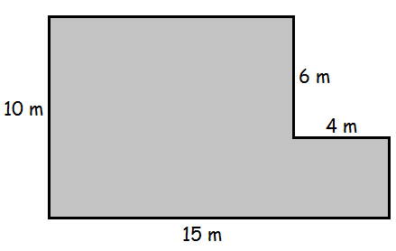](https://www.google.co.uk/url?sa=i&rct=j&q=&esrc=s&source=images&cd=&cad=rja&uact=8&ved=0ahUKEwjwwIWWzsjYAhXCK8AKHbW-CvwQjRwIBw&url=http://studymaths.co.uk/worksheets/40compoundshapes.html&psig=AOvVaw0u1lg95teDdX2nrsApzJ1k&ust=1515509276253464)

1. Greek Orthodox prayer room

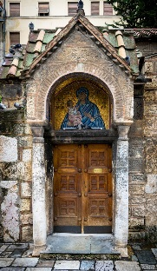

(1 square = 1 meter)

Challenge 1: The lengths of the sides of the bathroom are: 2m, 3m, 5m, 7m, 4m and 3m. Have a go at drawing it.

1. Bathroom

[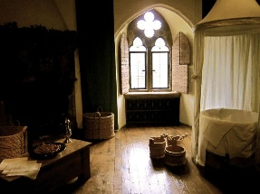](https://www.google.co.uk/url?sa=i&rct=j&q=&esrc=s&source=images&cd=&cad=rja&uact=8&ved=0ahUKEwi-vZ25wcjYAhUHCcAKHRc4D1cQjRwIBw&url=https://www.pinterest.com/anikin88/countess-elizabeth-bathory/&psig=AOvVaw14F3nOwBAGgORrsZphivNR&ust=1515505854298343)

Challenge 2: Draw your partner a rectangular composite shape to measure. Did they get it right?