ACT 1: Setting Description

Act 1 Summary:

Celebration
Caesar returns to Rome after winning the battle against Pompey and the people of Rome celebrate Caesar's return.

Soothsayer
As Caesar is parading back into Rome, he is approached by a soothsayer who shouts ‘Beware the Ides of March’ but Caesar dismisses the warning.

Cassius and Brutus
The senators Cassius and Brutus meet alone and discuss how they feel about Caesar. Cassisus is plotting against Caesar. Brutus is an honourable man.They both agree that Caesar has too much power and that this could be dangerous. Cassius implies that he has a plan and Brutus promises to consider it. Caesar sees them and tells Antony that Cassius has a ‘lean and hungry look’.

Caesar as King?
Casca (another senator) tells Brutus and Cassius that Antony offered Caesar a crown however Caesar refused it. Even though Caesar refused the crown three times, Casca is still convinced that Caesar wants to become king.

Cassius and the Conspirators
Cassisus believes that he can manipulate Brutus’ noble nature to join him in their plot to destroy Caesar. He meets with the other conspirators (Casca and Cinna) to formulate a plan.

Week 1 - Lesson 1: Rome Soundscape (Drama Lesson)
Learning Intention | To create a soundscape for a scene
Key Vocabulary | setting, scene, soundscape, freeze frame, tableau
Activities/  Lesson | Introduction  Explain that the play starts with the people of Rome celebrating Julius Caesar who has won the battle against Pompey. Introduce the idea of a soundscape - a combination of sounds that create an environment/scene. Introduce the setting of the opening scene of Julius Caesar. Explain that Caesar is arriving back in Rome after winning a battle and the people of Rome have been given the day off to celebrate and watch him return to the city. Show the children the following clips. (Teachers should watch all video clips before the lesson to check that they are appropriate for their class).  Animated Tales (0:00- 0:29). https://www.youtube.com/watch?v=7DtJkeMK0yU  Triumph of Caesar (1:50 - 2:33) https://www.youtube.com/watch?v=3GJLfHj9lfE  Ask the children what they saw in the clips.  Warm-up Activity  Children walk around the space, making sure they don’t walk too closely to anyone else and utilising all the space. The teacher calls a number and the children must dash to get into a group of that number. Repeat with different numbers. Finish with number five. Staying in these groups, and in silence, on the beat of a drum, children form different freeze frames of different structures e.g. crown, horse and chariot, adoring crowd. Encourage children to work together creating their shapes, using a range of height levels and bodily movements.  Main Activity - Creating a Soundscape  Play the following clip again but this time, tell the children to close their eyes and listen carefully to the sounds. Triumph of Caesar (1:50 - 2:33) https://www.youtube.com/watch?v=3GJLfHj9lfE Ask them to imagine being in the scene and experiencing the celebration. Did they hear the citizens shouting? What were they saying? ‘we love you Caesar’, ‘Glorious Caesar’ and repeated chanting of his name. Ask whether they heard any other sounds (loud cheering, trumpets blaring, horses hooves, horses neighing, clapping, roaring cheers etc). Divide the class into small groups and provide each group with a list of sounds from the scene and cheers from the crowd. Tell them that in their groups, they need to create a soundscape using their voices and bodies (cheering, drumming, trumpets, etc.). Allow time for each group to practice and refine their soundscape. Have each group perform their soundscape for the class, and discuss the different elements they included to represent the scene. Finally ask the children to perform their scenes at the same time to model the scale of noise, celebration and atmosphere of the scene.  Reflection and Writing Preparation  For the last part of the lesson, ask the children to reflect on their experience creating and performing the soundscape. Can you list as many sounds from the opening scene as possible? How did the sounds contribute to the atmosphere? What were the most powerful sounds?
Notes for Teachers | This lesson aims to engage students in a multisensory experience, immersing them in the atmosphere of the opening scene and preparing them for the upcoming writing task.
Resources | Animated Tales (stop at 0:29). https://www.youtube.com/watch?v=7DtJkeMK0yU  Triumph of Caesar ( 1:50 - 2:33) https://www.youtube.com/watch?v=3GJLfHj9lfE  Pictures or illustrations of ancient Rome for inspiration  Large open space for movement

Week 1 - Lesson 2: Using Our Senses
Learning Intention | To use the senses to describe a setting
Key Vocabulary | setting, sight, sound, touch, taste, smell, powerful
Activities/  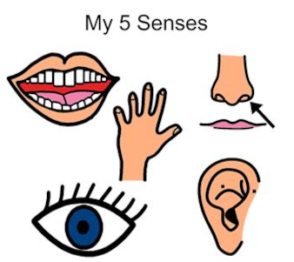  Lesson | Introduction  Start the lesson by asking the children - what is a setting? Ask for their input then explain that a setting is the environment/ surrounding that a story takes place in. Explain that it is important to create a powerful scene when writing a setting description. Explain how we can use the five senses: sight, sound, touch, taste, and smell to describe a setting. Remind the children of what they did in yesterday’s drama lesson and explain that we have used one of the five senses (sound) to help us to eventually write a setting description.  Exploring the Senses  Show the children a picture of people celebrating in ancient Rome (see example in resources). Discuss what they can see in the picture. What are people doing? What is the weather like? How would you feel if you were in the crowd? Explain that it is easier to describe what we can see when looking at a picture but that we have to use our imagination to describe using the other senses.  Introduce the five senses and explain that yesterday we explored the sounds that we would hear and that today we will focus on the remaining four senses (sight, touch, taste and smell). Split the children into pairs and give each pair an A3 copy of the Describe Using Senses template (see resources). Model using images of ancient Rome to list things that you could see, touch/feel, taste, smell. Ask the children to work in pairs to come up with as many things as they can for each sense. The children can use a range of images or video clips (from lesson 1) to support them..  Sharing  Allow children time to walk around the room and share/magpie 3 ideas for each sense from others children, picking the best ideas to write down on their sheet.  Plenary  Ask for one idea from each pair and make a note of these ideas on the board which can be displayed on the working wall.
Notes for Teachers | The aim of this lesson is for children to work collaboratively to list all the different elements of the opening scene that they can describe through the senses.
Resources | Animated Tales (stop at 0:29). https://www.youtube.com/watch?v=7DtJkeMK0yU  Triumph of Caesar ( 1:50 - 2:33) https://www.youtube.com/watch?v=3GJLfHj9lfE  Pictures or illustrations of ancient Rome for inspiration  Describe using Senses template (see resources)

Week 1 - Lesson 3: Similes
Learning Intention | To use similes to excite the reader
Key Vocabulary | similes, compare, like, as, language device
Activities/  Lesson | Introduction  Review the learning from the previous lesson- that we can create a powerful image for the reader if we describe using our different senses. Another effective way of creating a powerful image is to use figurative language/ language devices such as similes in your writing.  Introduction to Similes  Introduce the concept of similes as a language device. Explain that we use similes to compare two different things using the words "like" or "as" to create a picture in the reader’s mind. Provide examples of similes for children to explore- not necessarily linked to this particular context and ask them to decide what is being compared in these similes?  Individual Writing - Similes  Tell them that today we will be writing our own similes to describe the opening scene. Prepare some sentence starters generated from their work on senses in the previous lesson and ask them to use them to write their own similes. Model doing this on the board before asking them to have a go independently.  e.g.  People flowed onto the street like…  The midday sun was as hot as…  The city buzzed with excitement like…  The crowd surged forward like …  The crowds were as excited as…  Cheers erupted like…  White, marble buildings stood watching like…  Red banners flapped in the breeze like…  Sharing  Have the children share their similes. Provide positive feedback and discuss how these literary devices enhance the overall quality of the writing. Make a point that although we have generated several similes today, we would only use a couple in our final writing as the overuse of a language device can make it less effective thus having the opposite effect.
Notes for Teachers | Refer back to any previous learning of similes. You could use a range of images, video clips and passages from different versions of the play to support the children in building a mental image of the setting.
Resources | Examples of similes for children to discuss/explore  Animated Tales (stop at 0:29). https://www.youtube.com/watch?v=7DtJkeMK0yU  Triumph of Caesar ( 1:50 - 2:33) https://www.youtube.com/watch?v=3GJLfHj9lfE  Pictures or illustrations of ancient Rome for inspiration

Week 1 - Lesson 4: Personification

Learning Intention | To use personification to describe a setting
Key Vocabulary | personification, mood, violent, aggressive, noun, verb
Activities/  Lesson | Introduction  Review yesterday’s learning on similes. Explain that today we will learn to use a different language device- personification. Explain that personification is when we give human qualities to something that is not a human. Give the children a few examples of personification on the board and discuss each example so that they understand. Tell them that today we will use personification to describe Rome. Show the children pictures of Rome celebrating and ask them to spot things that they could personify. Ask children for their ideas and quickly make a list.  Main Teaching  Select a few examples from the children and write them up on the board. Pick the first noun and explain that in order to personify it, the inanimate object has to do something so we have to pair it with a verb. Show the first example of ask the children to generate verbs to personify the noun e.g. The banners - danced/waved proudly in the warm breeze.  Independent Activity  Once the children understand how to personify aspects of the scene, they can work in pairs to generate their own personification sentences. Make sure that they have access to a list of nouns they can personify.  Examples of noun to personify:  Banners, sun, flags, river, buildings, streets, marble columns, trumpets, flower petals, wind.  Plenary  Have the children share their sentences and read them aloud to the class. The class teacher can collect some examples for the working wall. Again mention that the overuse of a language device can make writing less powerful for the reader.
Notes for Teachers | Use a range of images, video clips and passages from different versions of the play to support the children in building a mental image of the setting. The children may need support in improving/extending their personification sentences.
Resources | Pictures or illustrations of ancient Rome for inspiration

Week 1 - Lesson 5: Write - Top to Bottom
Learning Intention | To use the senses to describe a setting
Key Vocabulary | setting, sight, sound, touch, taste, smell, language devices, similes, personification
Activities/  Lesson | Introduction  Explain that today we are going to write our setting descriptions based on the images we have seen. Display these on the board. Point out that it can be difficult to decide where to start when describing an image as there is so much going on thus so many starting points for a setting description. Tell them that today we will use a very simple method when using a picture to describe a setting. Show the children that we can describe a picture by firstly describing what we can see at the top and work our way down to the bottom. Briefly practise this with a picture of a setting displayed on the board( e.g. a picture of a forest). Allow children time to have a go with their talk partners.  Main Teaching  Using the top to bottom method reveal the top third of the picture of Rome celebrating. Ask the children to describe this part of the picture using their senses and language devices orally with their talk partner. Reveal the second third and ask them to describe what they can see now using their senses and similes. Finally reveal the bottom third of the picture and give them a chance to describe using their senses and language devices. Once they have had a go at describing the setting from top to bottom orally, refer to the working wall to refresh their minds on the work that they have done this week so that they can use the working wall while they write to remind them of language and ideas that they could magpie.  Write  Model using the ideas that the children have just generated to write the first part of the setting description (top third of the picture). Leave a sentence started up on the board for the children who need inspiration to get started, Allow children time to write their setting descriptions independently.  Plenary
Notes for Teachers | The aim of this lesson is for the children to use a method to use to describe a specific image.
Resources | Pictures or illustrations of ancient Rome for inspiration  Describe using Senses template (see resources)

Resources

Rome Celebrates

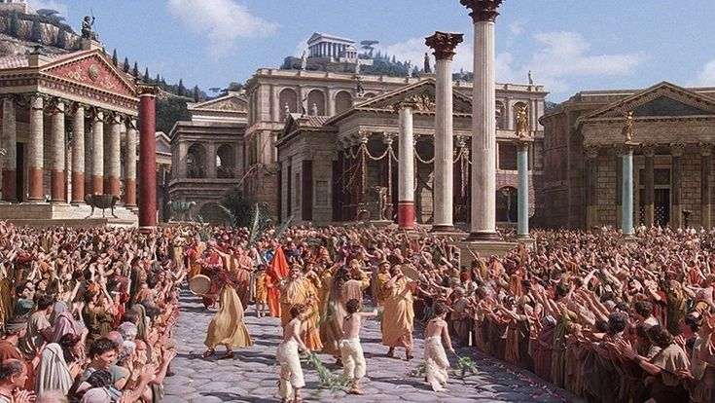
https://roman-empire.net/

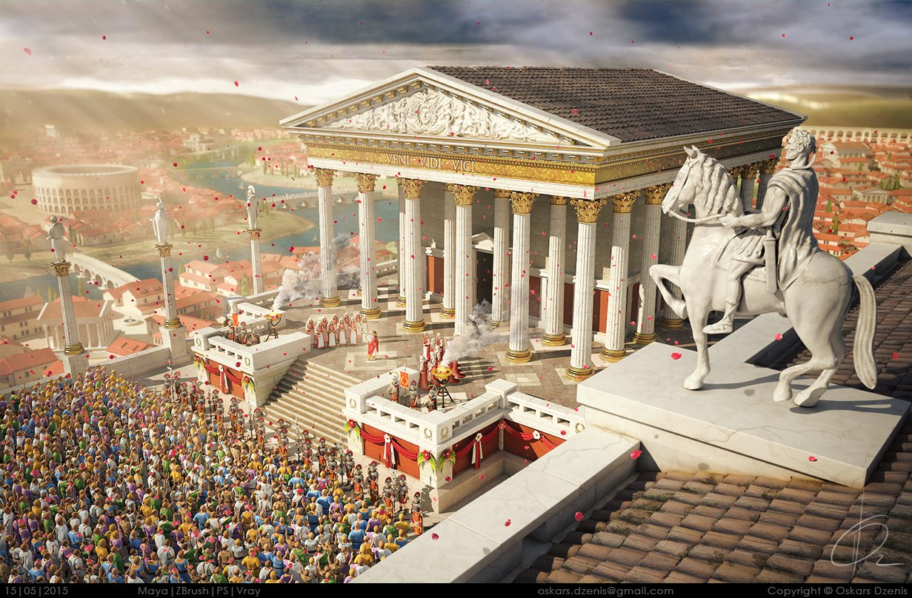
by Oskars Dezenis https://www.artstation.com/artwork/lG0bz

Describe Using Senses
