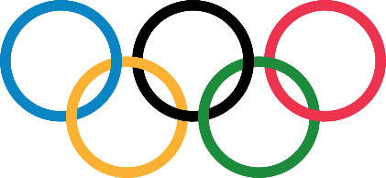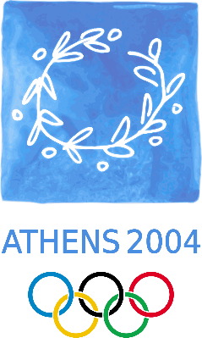 Athens Olympics

1896 Summer Olympics

1906 Intercalated Games

2004 Summer Olympics

|  |  |  |  |
| --- | --- | --- | --- |
| problem | estimate | answer | Check (inverse) |
| In 1906, there were 78 gold medals, 80 silver and 78 bronze medals handed out. In 2004, there were 301 gold medals, 300 silver and 326 bronze medals given out. How many more meals were given altogether over both Olympic Games? |  |  |  |
| In 1906, there were 78 gold medals, 80 silver and 78 bronze medals handed out. In 2004, there were 301 gold medals, 300 silver and 326 bronze medals given out. How many more meals were given out in 2004, than in 1906? |  |  |  |
| More than 10,534 athletes and 3,000 team officials from 202 countries will participate. **If** the athletes and team officials were evenly split between the 202 countries, how many would come from each country? |  |  |  |
| Afghanistan returned to the Games after a suspension in 1999, which was enforced partly because of the Taleban's ban on the participation of women athletes. How many months had they been banned for? |  |  |  |
| The Athens Olympic torch is designed to resembles an olive leaf. It weighs 748 grams and is 68cm long. What is the weight per gram? |  |  |  |
| Paul Henry Pilgrim (October 26, 1883 – January 8, 1958) was an American runner. He won three gold medals, in 1904 and 1906. How old was he at both Games? |  |  |  |