The Primary Shakespeare Company (PSC) are practising Act 5, Scene 3. They need to ensure they have all of the props ready for when the actors arrive so they visit a prop hire company. Help the PSC to work out the following problems so they know how many props they’ll have…

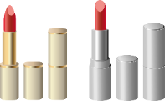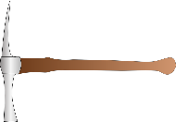Coins, Money, Pennies, Cent, Gold Coin, Silver Coin

9.

In a crate, there are 8 shovels and 5 lanterns. The PSC need 16 shovels and 6 lanterns. They buy 2 boxes. How many extra lanterns will they have?

8.

In a container there are 3 different shades of red lipstick: 1 rose, 2 burgundy and 3 sunset. If they buy 6 boxes. How many of each shade will they have?

2.

In a bag, there are 7 yew tree branches. The PSC need 29 branches. How many boxes will they need to buy?

4.

In a bouquet, there are 5 roses and 3 lilies. The PSC buy 7 bouquets. How many roses and lilies will they have altogether?

7.

In a bag, there are 4 gold coins, 6 silver coins and 3 bronze coins. The PSC need 13 gold, 11 silver and 10 bronze. How many bags will they have to buy?

6.

In a box, there are 14 envelopes, 15 piece of paper and 5 quills. PSC want 13 quills. How many envelopes will they also have to purchase?