The Capulet Property
In Act 2, Scene 1, Romeo is still at the Capulet property. Help measure the perimeter of the different rooms so it’s easier for Romeo to find his way around when dark...
Work each perimeter and area out in cm and m
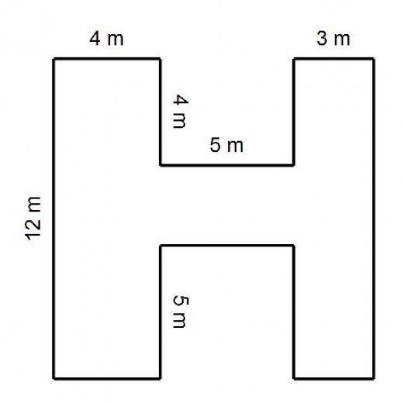
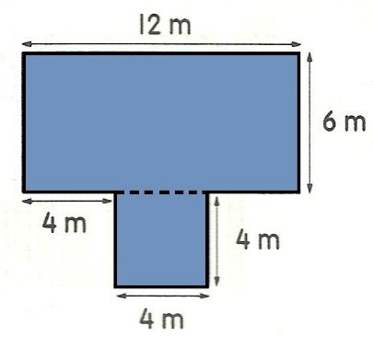
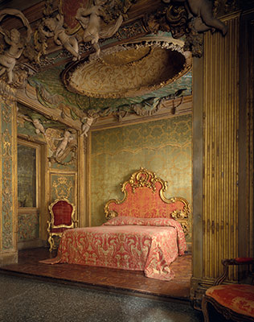
- Capulet’s Hallway
- Juliet’s bedroom
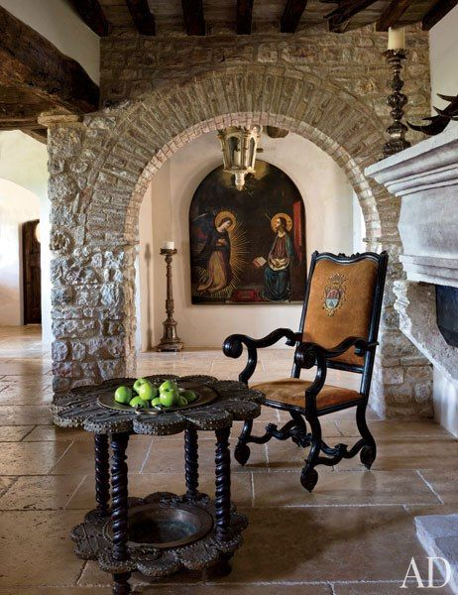

P = ……………………………… P = ………………………………
A = …………………………… A = ………………………………
- Kitchen
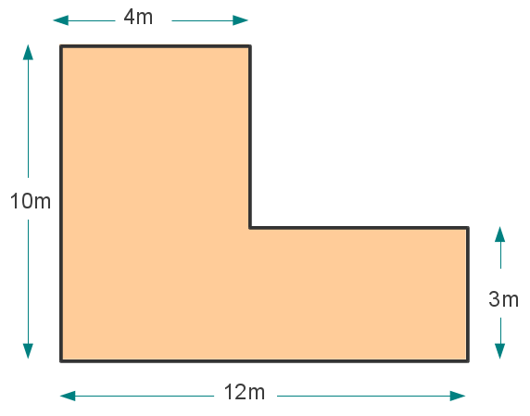
- Juliet’s Balcony
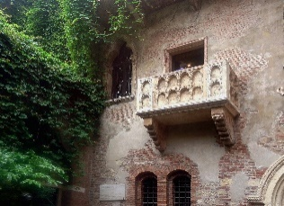
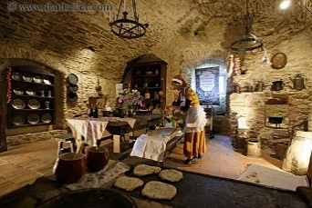

P = ……………………………… P = ………………………………
A = ……………………………… A = ………………………………
- Cellar

- Ballroom
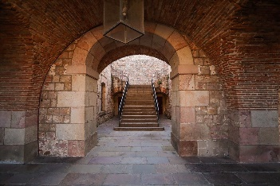
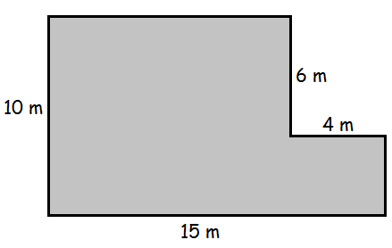
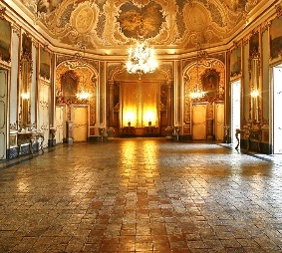

(1 square = 1 meter)
P = ……………………………… P = ………………………………
A = ……………………………… A = ………………………………
Challenge 1: The lengths of the sides of the bathroom are: 2m, 3m, 5m, 7m, 4m and 3m. Have a go at drawing it.

