ACT 2: Letter to Olivia

Summary of Act 2:

Sebastian and Antonio
Antonio saves Sebastian (Viola’s brother) from the sea and Sebastian is convinced that his twin sister Viola is dead. Antonio becomes very fond of Sebastian and follows him to Illyria despite the fact that he is an enemy of Orsino (the Duke of Illyria).

Viola/’Cesario’s’ Realisation
Malvolio gives ‘Cesario’ a message from Olivia saying that she is not in love with Orsino and is not interested in his ring. Viola realises that Olivia has fallen in love with ‘Cesario’ (her).

Malvolio Ruffles Feathers
Sir Toby (Olivia’s uncle), his friend Sir Andrew and Feste (Olivia’s jester) stay up late drinking and is told off by Malvolio (Olivia’s steward). They plan to get their revenge with the help of the maid, Maria. Maria decides to play a trick on Malvolio by making him believe that Olivia loves him.

Viola’s Love
Orsino discusses love with ‘Cesario’ and while in disguise Viola talks about her own feelings. Viola is talking about Orsino but Orsino assumes that ‘Cesario’ is talking about a woman. Orisno asks ‘Cesario’ to go to Olivia one more time.

The Letter
Maria writes a love letter to Malvolio pretending it is from Olivia. The letter asks Malvolio to wear yellow stockings, smile all the time and act a certain way to prove that he loves Olivia. When Malvolio reads the letter, he vows to do everything that the letter asks. Maria, Sir Toby and Sir Andrew watch Malvolio while hiding in a tree.

Week 1 - Lesson 1: Drama- Understanding the Characters
Learning Intention | To understand the traits and feelings of the different characters through drama
Key Vocabulary | frivolous, witty, cunning, sharp, controlling, serious, traits, tableau, feelings, emotions
Activities/  Lesson | - Display a picture of Malvolio and explain that he is a controlling, sober and serious character. Explain the adjectives to the children.  - Explore his character further on BBC Bitesize: https://www.bbc.co.uk/bitesize/guides/zw8tyrd/revision/5  Different Characters and their Traits  - Introduce all the characters found in the scene along with their character traits:  - Sir Toby and Sir Andrew (drunk and frivolous)  - Feste (clever and witty)  - Maria (cunning and sharp)  - Malvolio (Controlling and serious)  Starter- Call and Response  - Shout out each name and the children have to repeat the character traits back to you. Do this repeatedly until the children have memorised the character traits e.g. teacher: ‘Malvolio’ children: ‘Controlling and serious!’  - Ask the children to come up with an action/pose for each character to match their traits.  - Tell the children to walk around the room at a normal speed.  - Then tell them that you are going to shout out a number from 1 -5. The number will dictate the speed at which they need to walk (1 is very slow- 5 is a speedy walk). Practise this for a while. Encourage them to use any free space so that they do touch anybody when moving around the room.  - Tell them that you will shout out a character’s name. When they hear the name they have to respond by saying the character traits whilst acting out the pose/actions that they came up with earlier. Once they have done this they carry on walking around the room.  - Do this until the children are clear of the key characters and their personality traits and their responses are automatic and expressive.  Main Activity - Tableaus  - Explain that in Act 2 of Twelfth Night Malvolio upsets Sir Toby, Sir Andrew, Maria and Feste so they seek revenge by playing a trick on him. They decide to write a fake letter to him from Olivia. The letter states that Olivia loves him and wants to marry him and that she will love him even more if he does as she says in the letter.  - They plant the letter in the courtyard for Malvolio to find.  - Show different pictures of Act 2, Scene 5 (see resources for images).  - Ask the children: What is happening in the pictures? Which picture do they like the most? What is the mood in these pictures? Which one is Malvolio? How is he being portrayed in the pictures? How is everyone else feeling in the picture? Why?  - Explain to them that the pictures are taken from different versions of Twelfth Night showing the moment that Malvolio finds and reads the letter.  - Put the children into groups to recreate the tableaus of the moment Malvolio finds and reads the letter. Explain that they can pick a sentence from the letter to show Malvolio’s reaction when reading that particular sentence.  - Give each group a copy of the letter to refer to when they are creating their tableaus.  - Ask children to show their tableaus to the rest of the class.  - Take a photo of each tableau and allow children to give feedback on each group’s tableau.
Notes for Teachers | - This lesson will need to take place in a space where the children are able to move freely around the room.
Resources | - Images of Malvolio (see resources)  - Letterto Malvolio (see resources)
Week 1- Lesson 2: Writing the Introduction

Learning Intention | To write an introduction of a letter
Key Vocabulary | introduction, brief, who, what, where, when, why, address, greet
Activities/  Lesson | - Tell the children that this week they are going to write a letter in response to Olivia’s letter. Therefore they need to write from the perspective of Malvolio.  - Read the letter to the children (see resources- edit as you see fit) and have a discussion about it. Answer any questions that the children might have about the letter.  - Tell the children that today they will write the introduction. Explain that an introduction is usually brief and not detailed and should encompass the 5Ws (who, what, where, when, why)  - Ask the children to think about each W question and write down the ideas for each into the 5ws table (see resources).  Example:  Introduction - The 5 Ws  WHO Malvolio  WHAT He has found her love letter  WHERE In the courtyard/garden  WHEN Morning/afternoon/evening  WHY He is responding to let her know that he loves her too and will do as she has asked  - Once the children have come up with the ideas for each W, ask them how they think Malvolio would address/greet Olivia at the beginning of the letter.  Examples:  My dear beloved  My sweet darling Olivia  My Sweetheart  - Model thinking aloud while drafting the introduction of the letter on the board using the 5Ws.  - Ask the children to help you edit and improve what you have written.  - Make sure that all the children can see the ideas for the 5Ws.  - Allow children time to write the introductions to their letters.
Notes for Teachers | - Have the 5 Ws available to the children while they write their introduction.
Resources | - Letter to Malvolio (see resources)  - 5 Ws table (see resources)

Week 1 - Lesson 3: Generating Similes and Metaphors
Learning Intention | To generate similes and metaphors
Key Vocabulary | similes, metaphors, language devices
Activities/  Lesson | - Tell the children that today we are going to use similes and metaphors to describe Olivia’s beauty.  - Show the children a picture of Olivia (see resources) on the board. Ask them which features of Olivia would Malvolio want to compliment? Point out that not all features are physical. The children might come up with several features (eyes, glance, smile, hair, lips, laugh, voice, movement etc.) Write these features around the picture of Olivia displayed on the board.  - Explain that similes and metaphors are both language devices that we can use to describe Olivia’s features.  Similes  - Explain that a simile is when you compare two things using the words ‘like’ or ‘as’  - Model describing one of Olivia’s features using a simile ‘Your smile is warm like a summer’s breeze’  - Work with the children to generate 2 more similes together and write them on the board.  Metaphors  - Explain that a metaphor is when you describe something by saying that it is something else.  - Model describing one of Olivia’s features using a metaphor ‘Your eyes are glistening stars on a dark night’  - Work with the children to generate 2 more metaphors together and write them on the board.  Partner Work  - Give the children pieces of paper with a picture of Olivia in the centre and ask them to work in pairs to generate similes and metaphors to describe Olvia’s features.
Notes for Teachers | - Print an A4/A3 sheet with the image of Olivia for children to label and record their similes and metaphors
Resources | - Picture of Olivia (see resources)

Week 1 - Lesson 4: Describing Olivia’s Beauty
Learning Intention | To use figurative language to convey feelings
Key Vocabulary | similes, metaphors, figurative language
Activities/  Lesson | - Tell the children that today we will write the next paragraph of the letter. Remind the children that we are writing from the perspective of Malvolio.  - In this paragraph we are going to use some of the similes and metaphors that we generated yesterday to tell Olivia how beautiful she is and how much we (Malvolio) love her.  - Remind the children of some of the similes and metaphors generated in yesterday’s lesson.  Shared Writing  - Explain that today we will use the following sentence starter to start our paragraph.  I am writing to let you know that the feelings you have for me are matched by my love for you…  - Show them the following prompts and tell them that today we will use these prompts to help us write this paragraph.  How long have you loved Olivia for?  How does it feel when you see her walk by?  What are her most beautiful features?  How does she make you feel?  - When shared writing this paragraph, explicitly model using a simile and metaphor to describe her beauty when addressing the prompt ‘What are her most beautiful features?’  Independent Writing  - Allow the children time to read the shared write before they go to write their own paragraph.  - When the children are writing, make sure that they have access to the question prompts (see above) and similes and metaphors from yesterday.  - At the end of the lesson, ask a few children to read their paragraph in the voice of Malvolio.
Notes for Teachers | - When the children are writing, make sure that they have access to the sentence starter, questions prompts and examples of similes and metaphors from yesterday.
Resources | - Questions prompts (see above)  - Similes and metaphors generated in the lesson before.

Week 1 - Lesson 4: Modal Verbs
Learning Intention | To use modal verbs
Key Vocabulary | modal verbs, will, must, can, possibility, certainty, requests, respond
Activities/  Lesson | - Tell the children that today they will finish writing their letter. The final thing that we have to write is Malvolio’s response to ‘Olivia’s’ requests.  - Read the letter (see resources) with the children and ask them What has ‘Olivia’ asked Malvolio to do?  - Make a note of all the requests on the board and leave the requests on the board so that the children can refer to these later.  Requests  1) To be rude to his companions  2) To be mean to servants  3) To speak loudly about his ideas and opinions  4) To smile wildly  5) To wear his yellow stockings with cross laces  - Ask the children: Why has Maria ( who is pretending to be Olivia) asked Malvolio to do these things? Do you think Malvolio will do as the letter asks? Why?  - Explain that before we respond to the requests in our letter, we need to learn about modal verbs. Modal verbs are words that describe how likely things are to happen or to what degree of certainty something is known.  - Show the children a few modal verbs on the board and ask them if they can generate more.  - Then show them the following modal verbs- might, could, may, will, would, should, must, ought to and can.  - Group the modal verbs into 3 groups ask shown below and explain them to the children:  1) could, may, might - These words indicate that something might or might not happen.  2) would, should, ought to - These words indicate that something needs to happen but still  might not.  3) will, can, must - These words indicate a degree of certainty that something will happen.  - Ask the children which modal verbs Malvolio is most likely to use when replying to ‘Olivia’s’ requests? Why?  - Malvolio is most likely to use the last group as he wants to tell Olivia that he will follow all of her advice!  - Display the following starters on the board:  Modal Verb Starters  I will…  I can…  I must…  - Use the modal verb sentence starters above (and any others that the children come up with) to create sentences responding to the requests in the letter.  - Tell the children to write the final paragraph of the letter responding to the requests.  - Display the following sentence starter for the to start writing their final paragraph:  Final Paragraph Sentence Starter  Olivia, I would like to thank you for your advice. You are right. Next time I see the servants...  - Remind the children that after they have written this paragraph, they have to sign off the letter with an appropriate sign off.
Notes for Teachers | - Display the requests, relevant modal verbs and final paragraph sentence starter for the children to refer to when they are writing.
Resources | - Letter (see resources)
Week 1 - Lesson 5: Editing, Improving and Publishing
Learning Intention | To edit, improve and publish writing
Key Vocabulary | edit, improve, publish, mistakes, punctuation, spelling, synonym
Activities/  Lesson | Editing and Improving  - Display a chosen piece of work on the board and read aloud to the class.  - Model how to edit and improve the letter using the editing checklist (see resources for printable version).  Editing Checklist  Capital Letters  Sentences begin with a capital letter.  Proper nouns have capital letters.(A proper noun is: a person’s name, a place or organisation)  The pronoun “I” is written with a capital letter.  Punctuation  Full stops are where they should be.  Question marks and exclamation marks are used when necessary.  Apostrophes are used to signal missing letters or to show possession.  Grammar and Spelling  I have used classroom resources to check spelling and all words are spelt correctly..  Organisation  I have started the letter with a greeting and signed off with the sender’s name  Paragraphs have been used to break up the text.  The writing makes sense.  - Allow children to work alone or in pairs to edit and improve their letters.  Publishing  - Once the children have edited and improved their letters allow them time to publish their letters on the chosen paper.
Notes for Teachers | - Before the lesson, choose a piece of work to display on the board to model editing and improving.
Resources | - Editing Checklist (see resources)  - Prepare the type of the paper that you would like the children to use when publishing their letter.

Resources

Images of Malvolio reading the letter

Images from past performances of The Twelfth Night at the Royal Shakespeare Company.

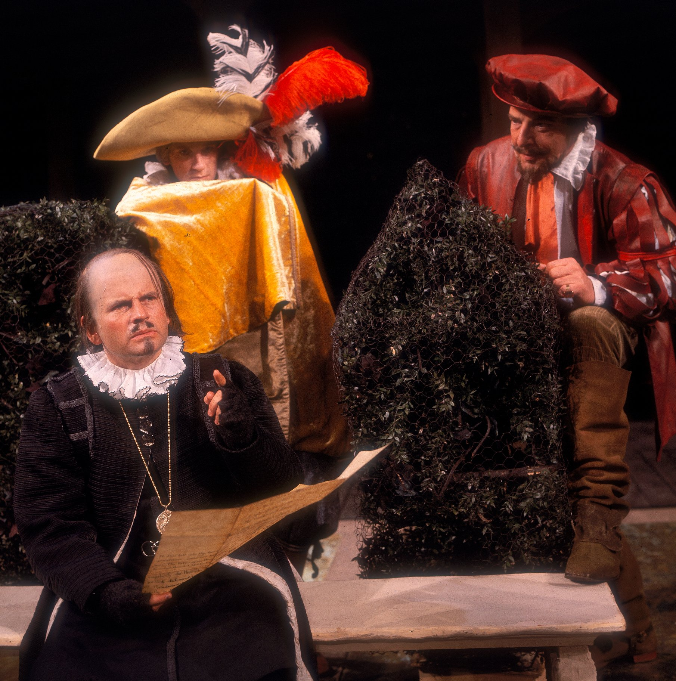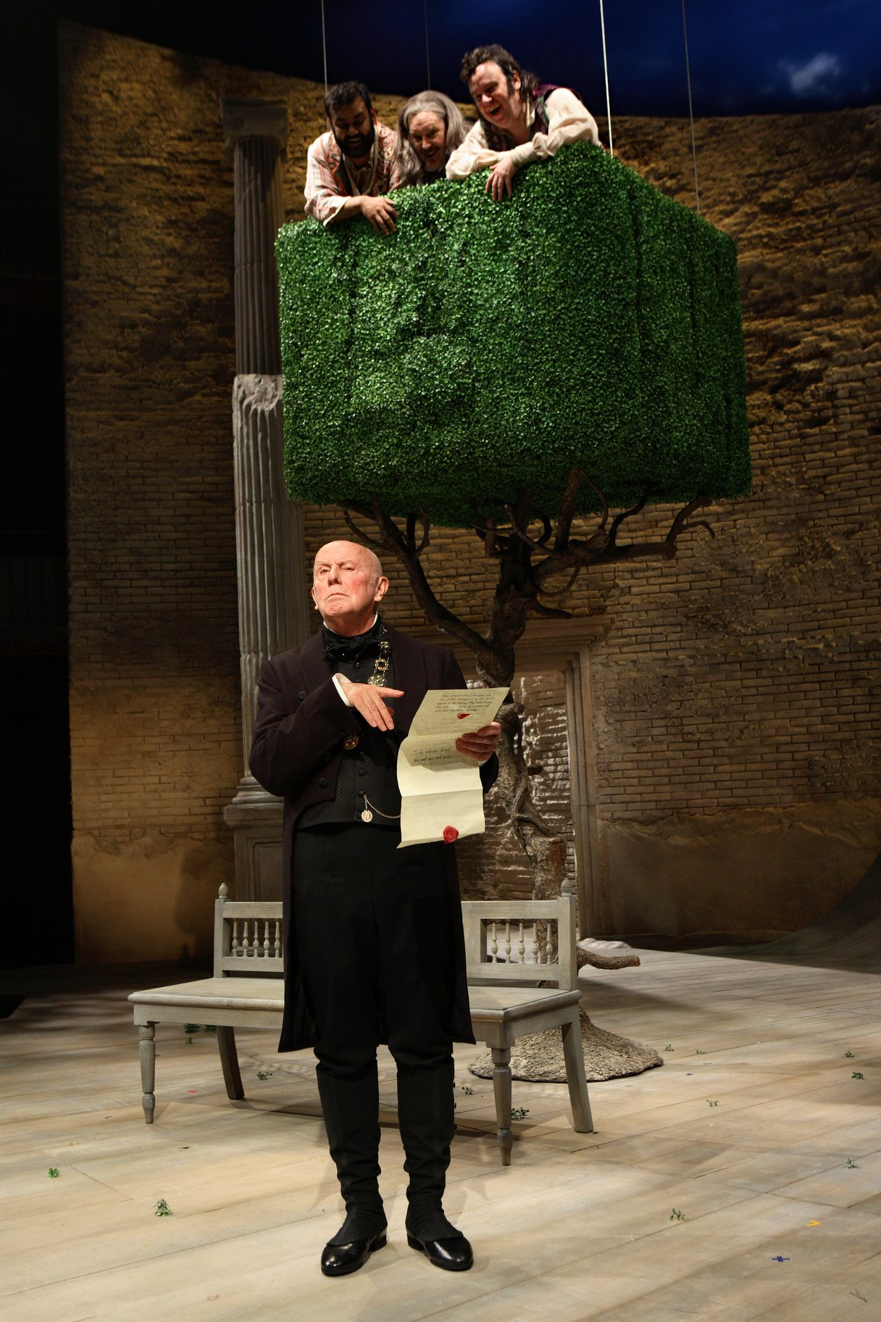

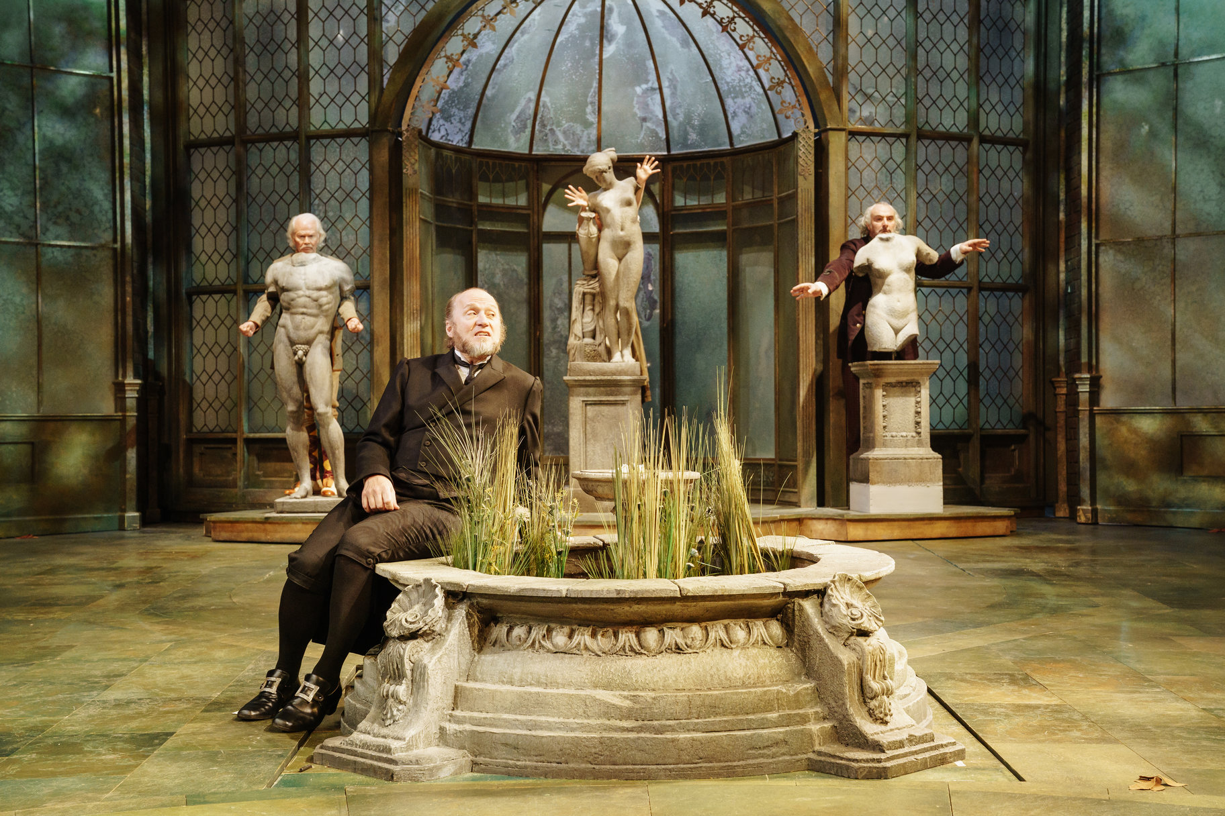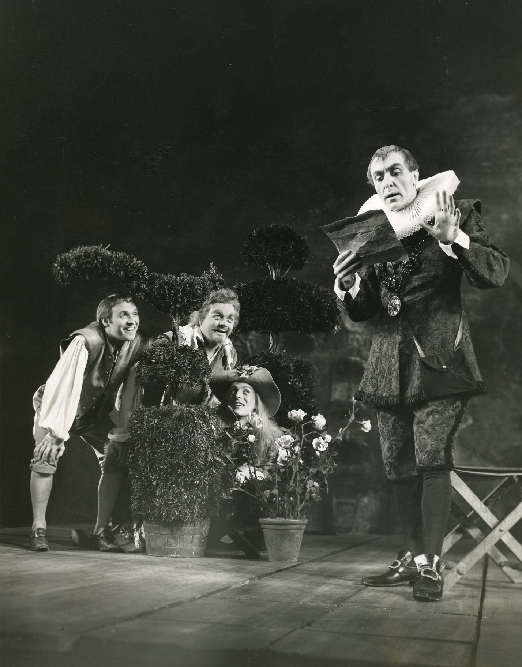

Letter to Malvolio

To my beloved,

You do not know of my love for you but I am sending you this letter and my good wishes. God knows that I love you and always have but this must stay a secret between us. Noone must know. You may serve me but I love you and I hope this letter will fall into your hands and your hands only. By birth, I am ranked above you, but don’t be afraid of my greatness. Some are born with greatness and some achieve greatness! Greatness is coming to you and you must prepare yourself for the upper-class life you will soon have. You need to forget your old self and become a new, fresh person. Be rude to your companions and be mean to the servants. You should smile wildly and talk loudly about your ideas and make a habit of being unique and eccentric. The woman who loves you is asking you to do this. Do you remember when I complimented your on your yellow stockings? You look so dashing when you wear them with the crossed laces up your legs - I do hope to see you in them again. You are assured of becoming a gentleman, if you want to be. If not, just keep acting like a lowly steward, a companion of servants, and not worthy to grasp the greatness before you. Farewell. Signed, one who would switch places with you and be your servant.

Yours truly,
The one you serve

Introduction - 5Ws Grid

WHO

WHAT

WHERE

WHEN

WHY

Image of Olivia
Dasha Petrenko/Shutterstock.com

Editing Checklist

Editing Checklist
Checked | I have checked that:
 | Capital Letters
 | Sentences begin with a capital letter.
Proper nouns have capital letters.
(A proper noun is: a person’s name, a place or organisation)
 | The pronoun “I” is written with a capital letter.
 | Punctuation
 | Full stops are where they should be.
 | Question marks and exclamation marks are used when necessary.
Apostrophes are used to signal missing letters or to show
possession.
 | Grammar and Spelling
 | I have used classroom resources to check spelling and all words are spelt correctly.
 | Organisation
 | I have started the letter with a greeting and signed off with the sender’s name
 | Sentences are written in an order that makes sense.
 | Paragraphs have been used to break up the text.
 | The writing makes sense.

