What’s the time Mr. Camillo?

1. A producer is confused about the order of some of the events involving Camillo happen. Help her to read the times. All of the times are pm.

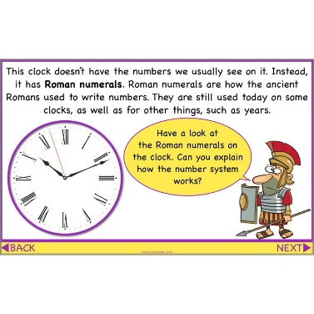

Camillo makes it clear that he thinks Polixenes’ extended stay is for the happiness of Leontes and Hermione – ‘To satisfy your highness and the entreaties of our most gracious mistress.’

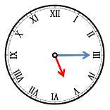

Camillo says, ‘You had much ado to make his anchor hold: When you cast out, it still came home.’

[](https://www.google.co.uk/url?sa=i&rct=j&q=&esrc=s&source=images&cd=&cad=rja&uact=8&ved=0ahUKEwiI4q6s0MjYAhWqA8AKHVyyCqYQjRwIBw&url=http://www.middlewichvirtualmuseum.co.uk/session-plan-3/&psig=AOvVaw0Owcf6TUTwdA4mPm7b6Gy1&ust=1515509858577775)

Camillo enters the room where Leontes and Mamillius are.



Camillo gives his soliloquy, expressing his disgust at being asked to posion the ‘good Polixenes’.



Polixenes enters and Camillo greats him, ‘Hail, most royal sir!’

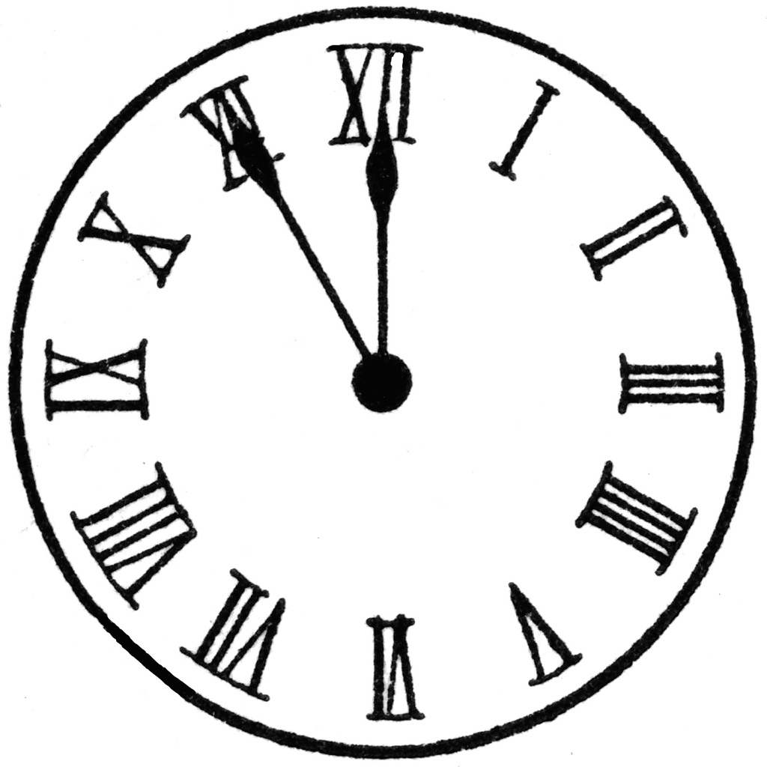

Camillo leads Polixenes away, ‘Come, sir, away.’



Leontes believes Camillo knew about the affair, ‘she's a traitor and Camillo is A federary with her.’

1. Order the times from the earliest to the latest.



1. Now write 3 events that take place in your day, i.e. going to school or eating lunch. Write the event and then write the time in Roman Numerals as well as drawing the hands correctly on the clock.

